**PART B**

**AIM OF THE PROJECT : WORKING CIRCUIT OF ELECTRONIC DICE .**

**BRIEF DESCRIPTION :**

1. THE ELECTRONIC DICE IS USED IN ALL TYPE OF GAMES WHERE A NORMAL DICE IS USED.
2. THE ELECTRONIC DICE USED SO THAT NO ONE CAN CHEAT WHILE PLAYING A CERTAIN GAME.
3. THE PROJECT CONSIST OF 7 LED ARRANGED IN ‘H’FORMAT AND THE RESPECTIVE NUMBER DISPLAYED BY GLOWING THE REQUIRED LED.
4. THE ELCTRONIC CIRCUIT IS BIASED AND CAN BE RE-BIASED IF IT BECOMES UNBIASED.
5. THE 1 ST LED GLOWS IF THE COUNT IS 1 AND THE 2 LED WILL GLOW IF THE COUNT IS 2 AND SO ON.
6. THE IC 4017 IS KNOWN AS DECADE COUNTER.
7. IT ALSO CONSIST OF OTHER COMPONENTS SUCH AS BREADBOARD,LED ,+5V FIXED POWER SUPPLY AND CONNECTING WIRES.

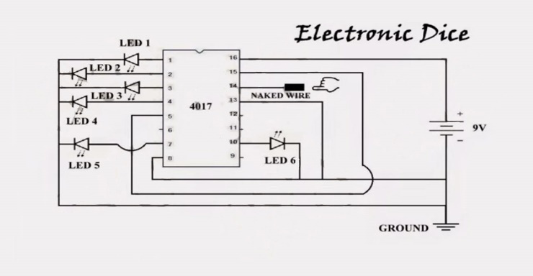

**AIM OF MICRO PROJECT :**

THIS MICRO PROJECT AIMS AT:

* STUDY THE WORKING PRINCIPAL OF ELECTRONIC DICE.
* •STUDY ABOUT THE STRUCTER OF IC 4017 AND ITS USES.
* •STUDY ABOUT THE CIRCUIT CONSTRUCTION OF ELECTRONIC DICE

**COURSE OUTCOME INTEGRATED :**

* INTERPRET THE WORKING OF IC 4017 IN ELECTRONIC CIRCUIT.
* BUILD SIMPLE SEQUENTIAL CIRCUIT.

**ACTUAL PROCEDURE FOLLOWED :**

1. **GROUP FORMATION:-** DTE IS A SUBJECT IN WHICH WE STUDY ABOUT SOME DIGITAL EQUIPMENTS. THE BASIC AIM OF MICRO- PROJECT IS TO ACCELERATE THE ATTAINMENT OF THE VARIOUSE OUTCOME IN THE COURSE.IN THE FIRST 2 WEEKS OF AUGUST THE SUBJECT WAS INTRODUCED .THE SYLLABUS AS WELL AS DETAIL OF MICRO-PROJECT WAS DISCUSSED.THE GROUP OF 3 MEMEBERS WERE FORMED AND THE GROUP LEADERS WERE SELECTED.THE SCHEDULE OF PLAN “A”,”B”& “PRESENTATION” WERE FINALIZED.THE VARIOUSE MICRO-PROJECT TOPICS RELATED TO SUBJECT WAS DISCUSSED OUR GUIDE GAVE US THE OPPORTUNITY TO SELECT THE TOPIC OF OUR CHOICE.
2. **FINALIZATION OF MICRO-PROJECT:-** AFTER ATTENDING THE LECTURES FOR 2 WEEKS.WE SELECTED THE TOPIC FOR MICRO-PROJECT.WE DISCUSSED THE TOPIC WITH OUR GUIDE REGARDING THE CONCEPT WHICH WE ARE GOING TO APPLY IN THE PROJECT.WE INDIVIDUALLY TRIED TO EXPLAIN THE BASIC PLATFORM OF PROJECT.
3. **PLANNING:-** AFTER FINALIZATION OF THE PROJECT WE STARTED WORKING ON THE PROJECT.WE STARTED THE PLANNING PHASE.WE DISCUSSED AMONG OURSELVES REGARDING THE RESOURCES SUCH AS BREADBOARD, IC REQUIRED ,LED ETC IN THIS WEEK WE COMPLETED ‘PART A PLAN’ OF THE MICRO-PROJECT WHICH IS NOTHING BUT A INITIAL DESCRIPTION ABOUT THE PROJECT.WE SUBMITTED IT TO THE GUIDE.
4. **MODULE DISTRIBUTION &ANALYSIS PART:-** ONCE THE PLANNING WAS OVER REGARDING RESOURCES,ETC. WE DISTRIBUTED THE DIFFERENT MODULE AMONG US.WE ALSO STARTED THE ANALYSIS OF PROJECT.
5. **IMPLEMENTATION :-** IN THE WEEK WE ACTUALLY STARTED THE TECHNICAL PHASE .IN THIS PHASE WE TECHNICALLY STARTED MAKING THE CIRCUIT. EACH AND EVRY STUDENT HELPED IN MAKING AND TESTING THE CIRCUIT .FINALLY THE PROJECT WAS WITHIN THE SCHEDULE TIME.
6. **PRESENTATION :-** IN THIS WEEK WE HAVE TO PRESENT THE MICRO-PROJECT IN FRONT OF THE GUIDE.THE WHOLE GROUP PRESENTED THE WHOLE PROJECT WITH CONFIDENCE IN FRONT OF GUIDE.SHE ASKED US VARIOUSE QUERIES REGARDING THE TOPICS.WE PRESENTED THE DETAILS OF EACH CONCEPT OF THE TOPIC .SHE ASKED US TO DO VARIOUSE CHANGES REGARDING SOME TOPICS.
7. **SUBMISSION:-** THIS WEEK WAS SUBMISSION WEEK.WE SUBMITTED OUR PROJECT ALONG WITH ‘PART A & B PLAN’ TO THE GUIDE.WE ALSO SUBMITTED THE WORKING CIRCUIT AND SOFT COPIES OF PART A & PART B TO THE GUIDE

**OUTPUT/ TRUTH TABLE: -**

|  |  |  |  |  |  |  |
| --- | --- | --- | --- | --- | --- | --- |
| **INPUT** | **OUTPUT** | | | | | |
| **QA** | **QB** | **QC** | **QD** | **QE** | **QF** |
| **0** | **0** | **0** | **0** | **0** | **0** | **0** |
| **1** | **0** | **0** | **0** | **0** | **0** | **1** |
| **2** | **0** | **0** | **0** | **0** | **1** | **0** |
| **3** | **0** | **0** | **0** | **0** | **1** | **1** |
| **4** | **0** | **0** | **0** | **1** | **0** | **0** |
| **5** | **0** | **0** | **0** | **1** | **0** | **1** |
| **.** |  |  |  |  |  | **.** |
| **.** |  |  |  |  |  | **.** |
| **62** | **1** | **1** | **1** | **1** | **0** | **1** |
| **63** | **1** | **1** | **1** | **1** | **1** | **0** |
| **64** | **1** | **1** | **1** | **1** | **1** | **1** |

**ACTUAL RESOURCES USED:**

|  |  |  |  |
| --- | --- | --- | --- |
| **SR NO** | **NAME OF RESOURCE/COMPONENT** | **SPECIFICATION** | **QUANTITY** |
| 1 | LED | GREEN | 7 |
| 2 | IC | 4017 | 1 |
| 3 | BREADBOARD | 5.5* 17 CM | 1 |
| 4 | CONNECTING WIRE | ANY COLOR | 1 MTR |
| 5 | BATTERY | 30V | 1 |

REFERENCES

WE DO HAVE USED A FEW REFERENCES DURING THE PROCESS OF BUILDING OUR PROJECT. THE REFERENCES USED ARE FROM WEBSITES, BOOKS ETC.

THE REFERENCES USED ARE:

WEBSITES:

1: WWW.QUORA.COM.

2: WWW.ELPROCUS.COM.

3: WWW.NIDEC.COM.

REFERENCE BOOKS:

1:DIGITAL ELECTRONICS

2: DIGITAL ELECTRONICE ,PRINCIPLES AND INTEGRATED CIRCUITS.

**SKILL DEVELOPED/LEARNING OUT OF THIS MICRO PROJECT :**

WE HAVE LEARNED TO WORK AS A GROUP, SHARE DATA. WE HAD LEARNT HOW TO HAVE ACTIVE DISCUSSIONS